

**Indian Institute of Information Technology, Allahabad**

**User Manual**

**PROJECT 59:**

**AKSHAY ANSHUL(IIB2019015)**

**GAURAV YADAV (IIB2019022)**

**ADITYA RAJ (IIB2019023)**

**PRITIK SHRIVASTAVA (IIT2019192)**

**IMPLEMENTATION DETAILS :**

**1) Installing Atom**

**This is a great editor that we have used.**

[**https://atom.io/**](https://atom.io/)

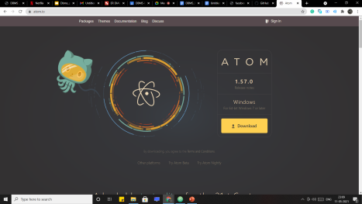

2-)Installing terminal and django in ATOM:

Install the two packages listed on top in the installed package list here.

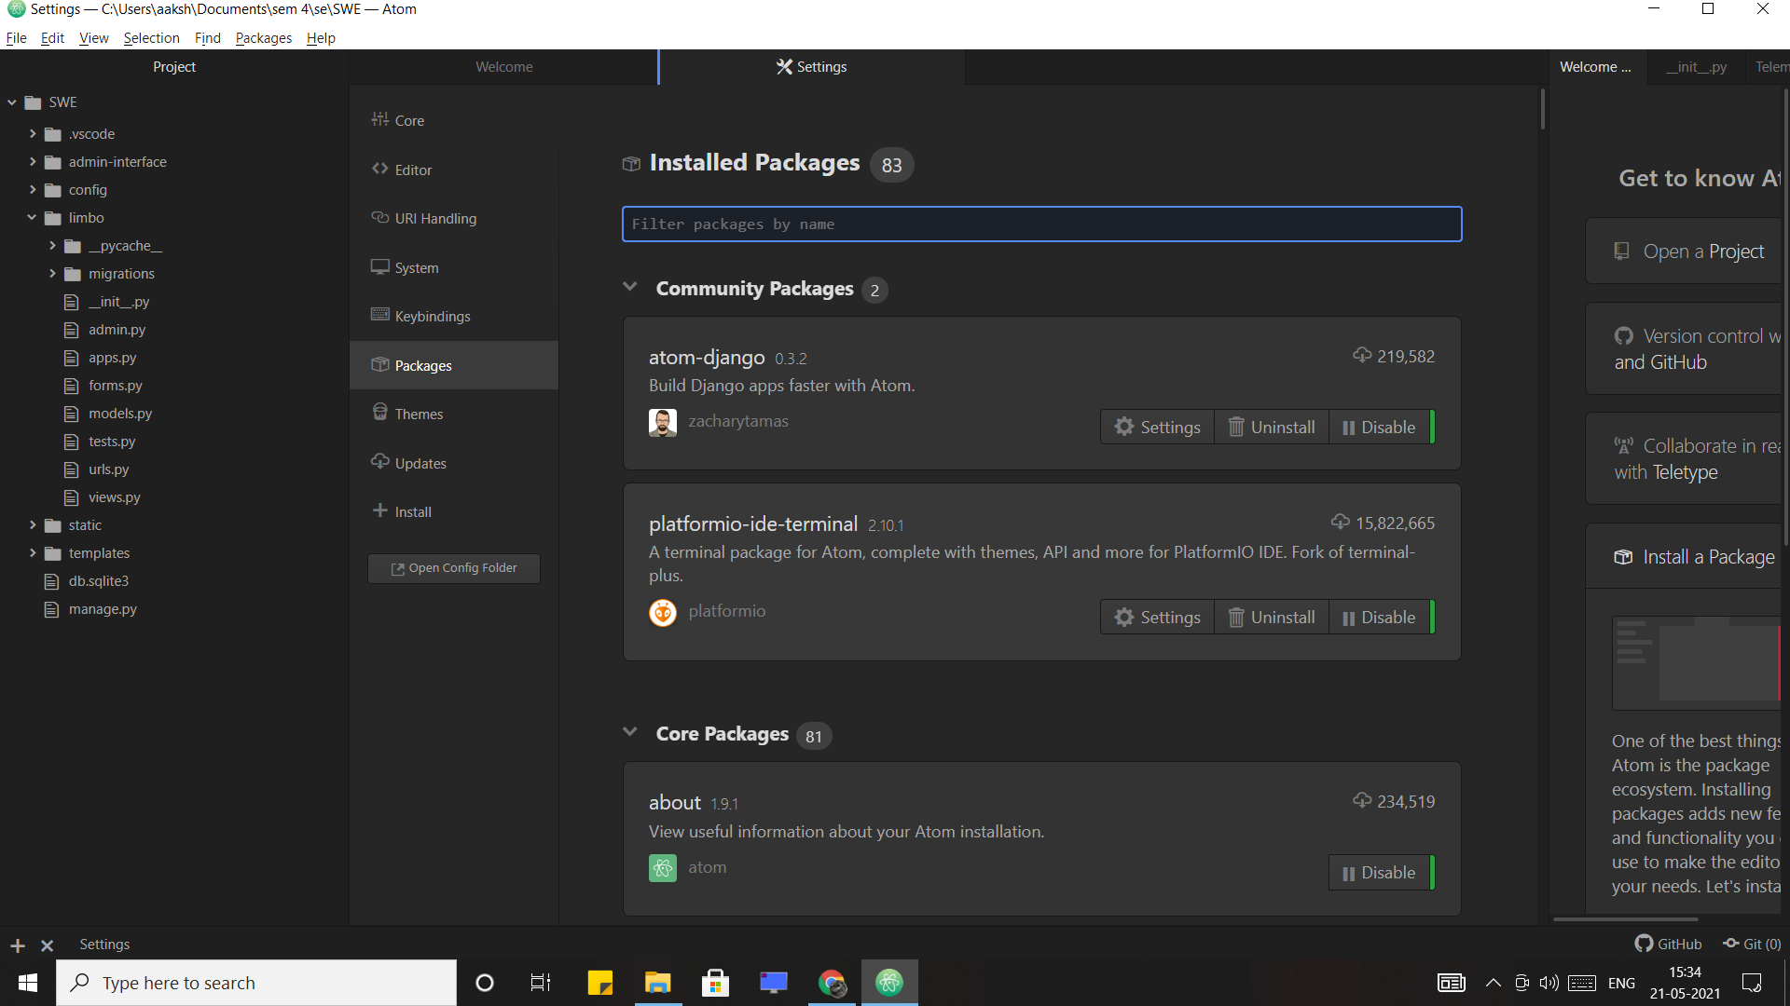

After we install the terminal we get a + sign on the bottom left corner where we can access terminal .

Next we will install Django into our terminal with the following command: **:**

**pip install django**

**Next we install python**

[**https://www.python.org/downloads/**](https://www.python.org/downloads/)

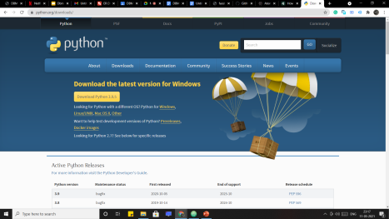

Next we install Some required packages with the following commands in our atom terminal:

**pip install django-admin-interface**

Next we will add our project folder to atom.

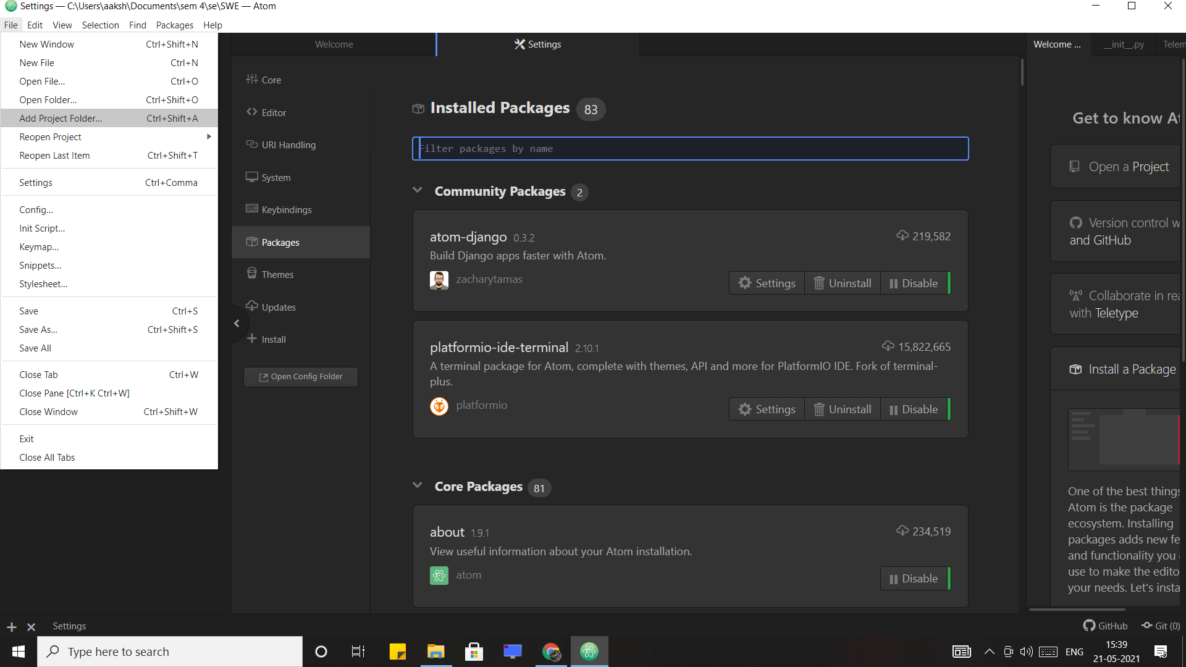

Then we click the plus sign at the bottom and we can see the terminal is already navigated to our project folder**.**

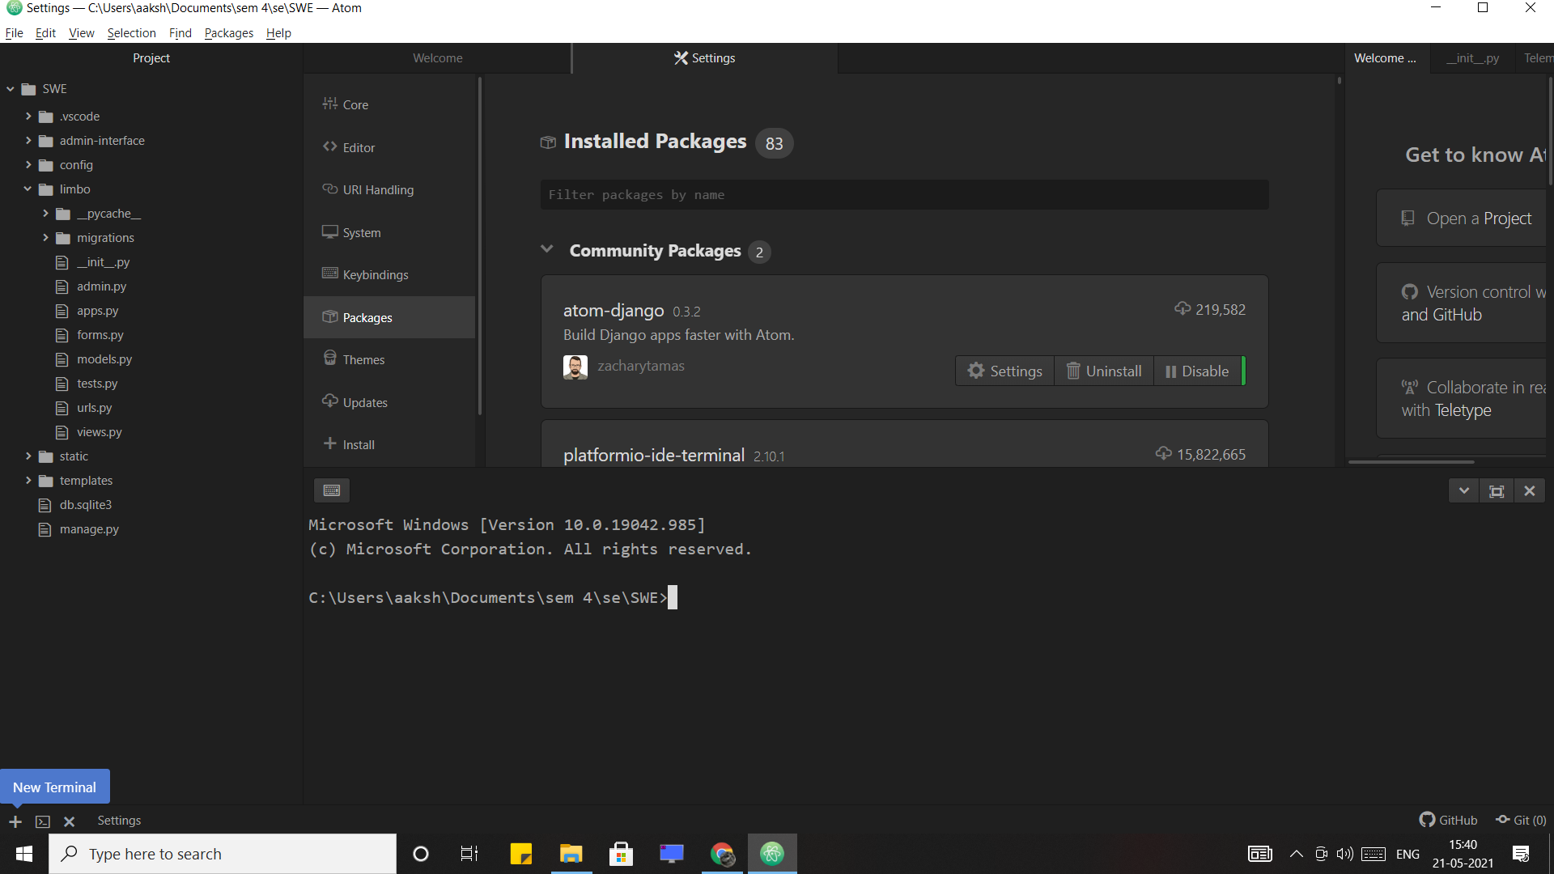

We are now very close to running our project but before running it we need to make sure that our database gets populated .For that we run these two commands:

**python manage.py migrate**

**python manage.py makemigrations**

Now we can run our project

Simply type in the terminal :

**python manage.py runserver**

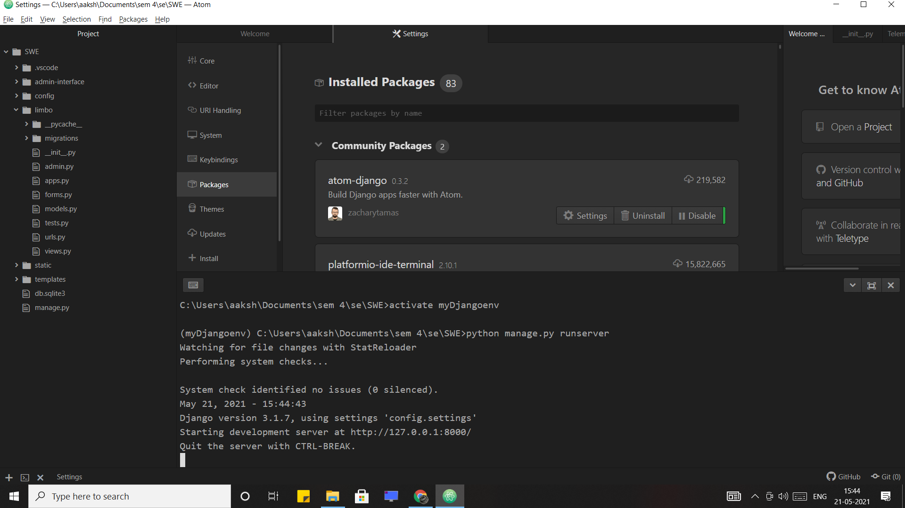

If you have done correctly till now,you can see the message as seen in the screenshot above.

We can press **ctrl+c** to stop the server.

We can go to <http://127.0.0.1:8000/> this link after server is running to start using our app.

Our App contains multiple users and every user exercises different functions.So we need login details to login and use these functions.

**Here is the snapshot of our log in page for all the actors:**

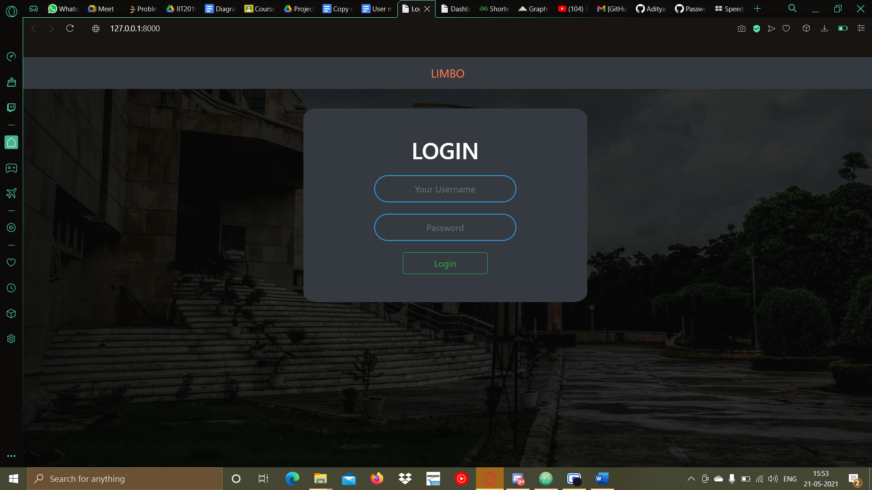

**The log in credentials corresponding to each actor is given below:**

